1.

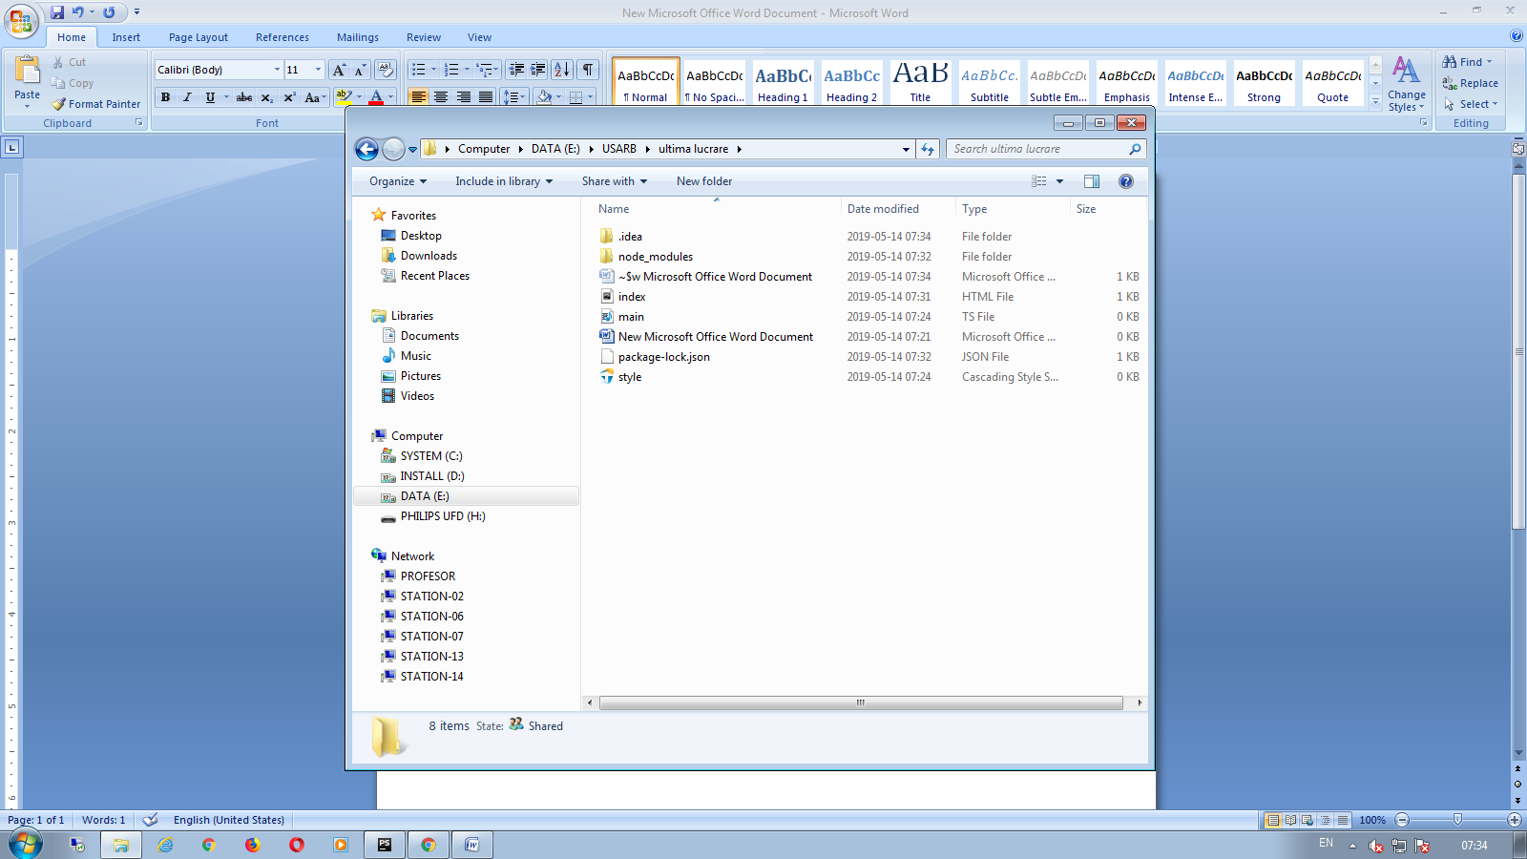

2.npm install

3. npm install boostrap

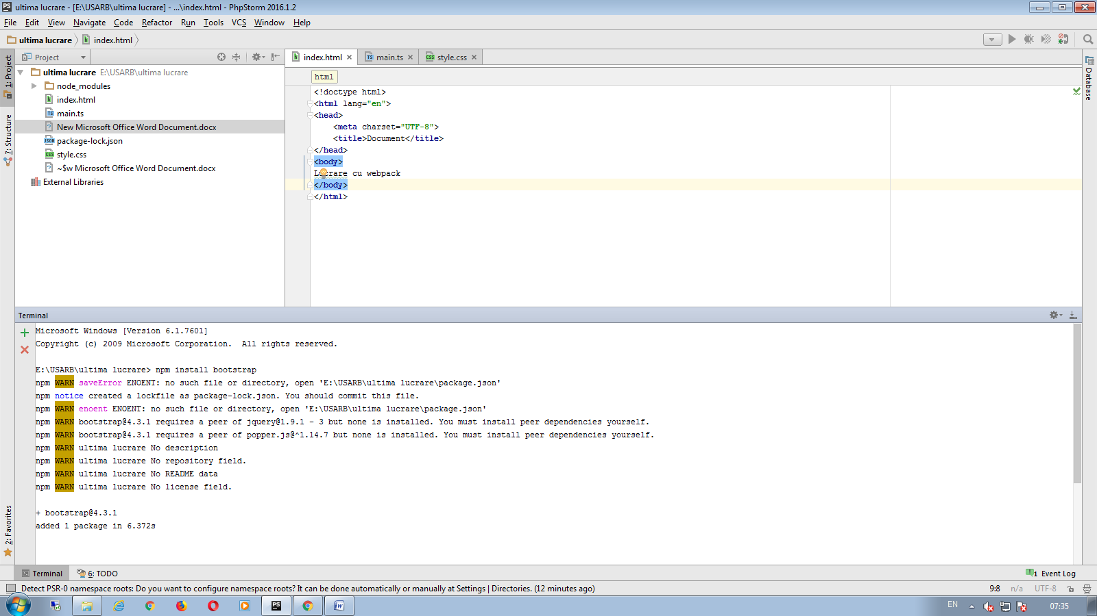

4.tsc main.ts

5.

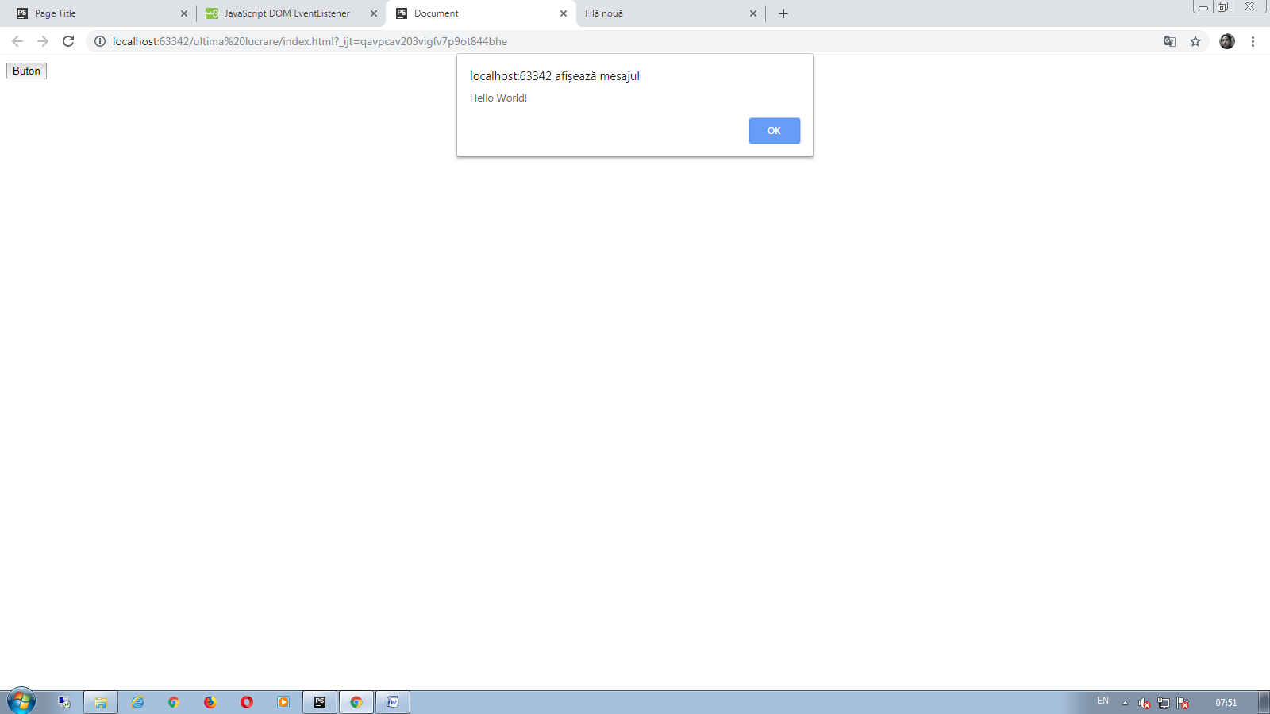

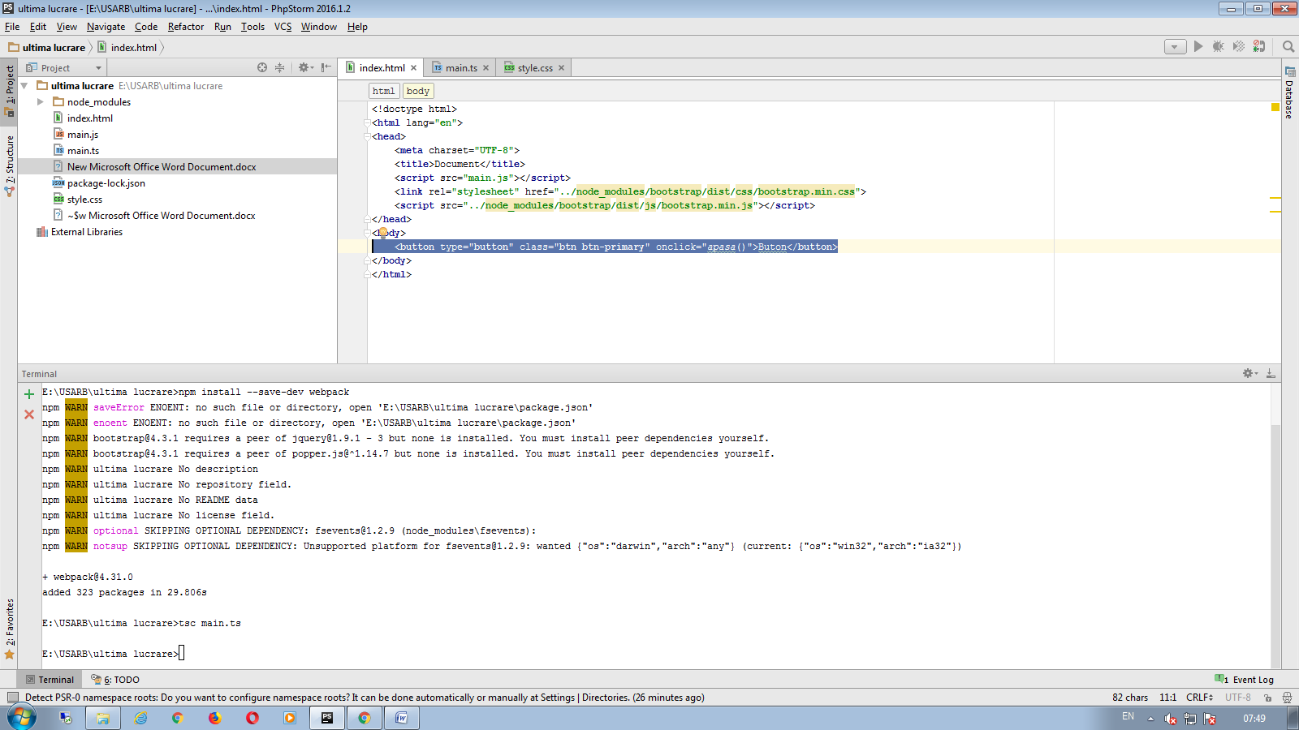

6.

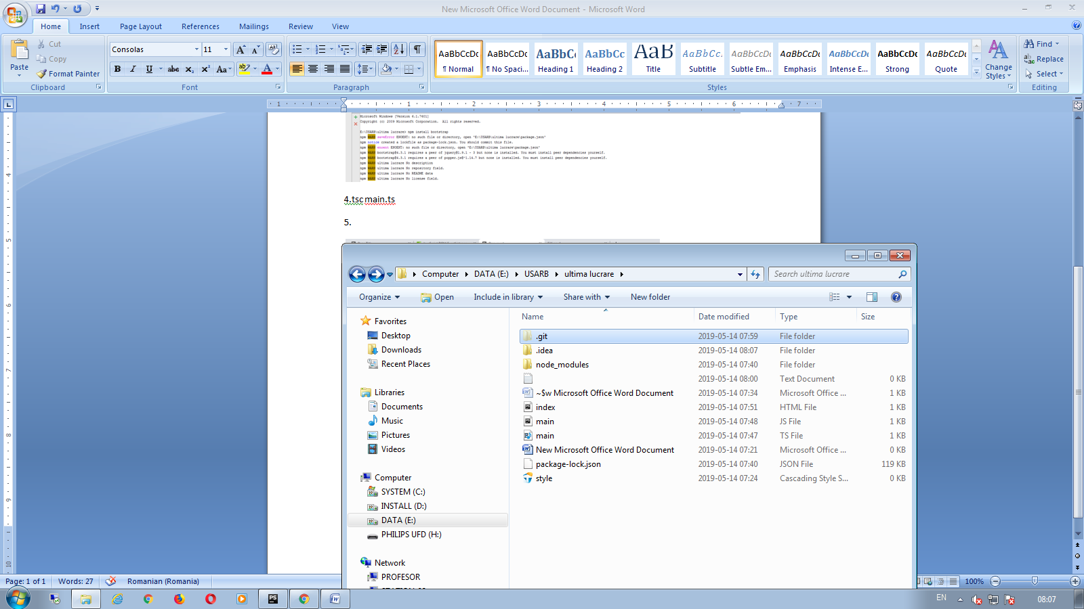

git init

echo “node_modules/”>>.gitignore

git add*

git commit – m “my commit”

7. npm install –g json server

8. npm install --save-dev webpack

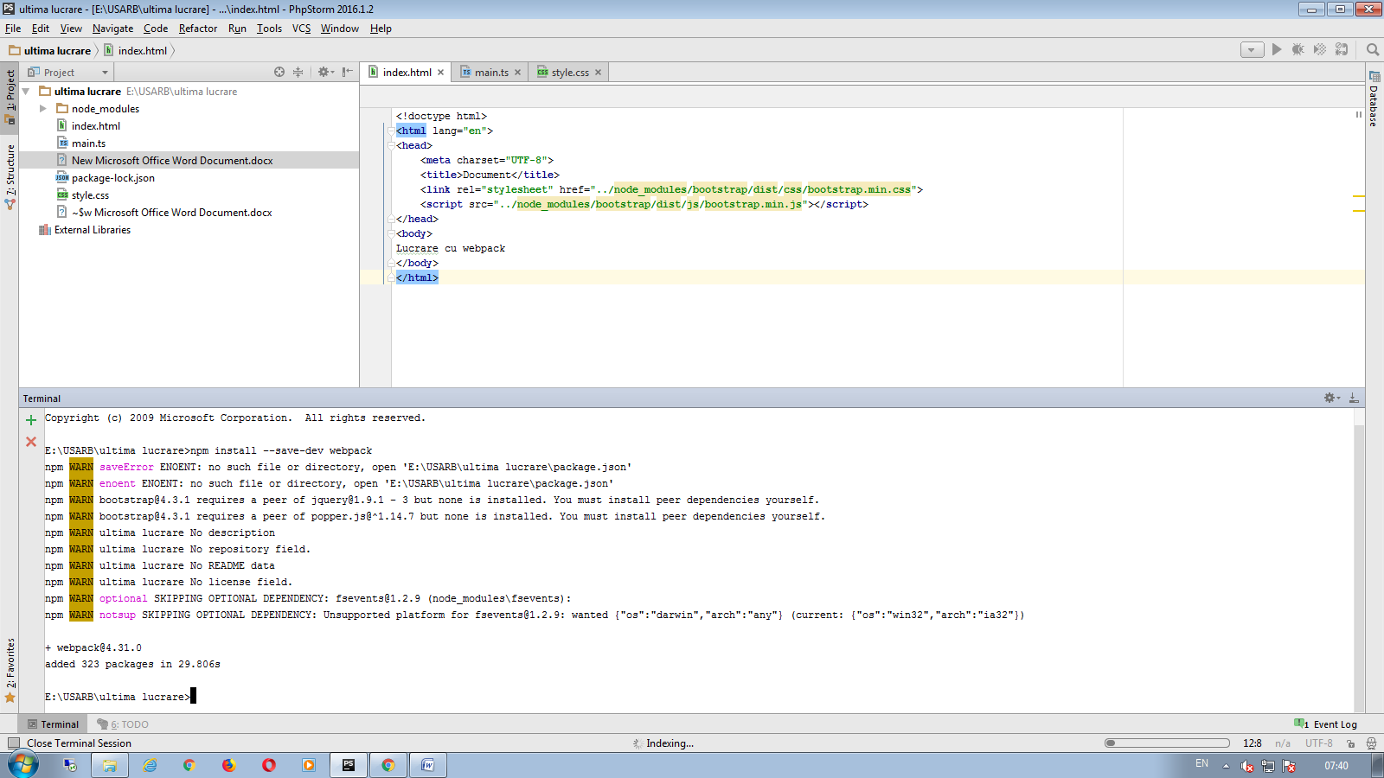

12. npm install css-minify –g